# Bug 2 Hypothesis:

Regarding Bug 2, the best place to start would be the function “balanceExceedsLimitBy” starting on line 42 in Player.java, and ending on line 44.   
The primary problem with this function, is that “balanceExceedsLimitBy is returning a “false” value when the player still has a balance of “5”. Testing this function involves toggling a breakpoint at line 42 and stepping into the function.

### Evidence within Debugging:

### 

### Sane/Infected:

From above we can see up until this point, the value is Sane, however after the value passes through this function, it converts the value to infected due to the fact the program considers the Limit exceeded, even though, realistically it is not due to the bug in the code.

This can simply be fixed by changing the “>” tag to a “>=” tag. This will ensure the user is still able to make a bet with a balance of% $5.

# Bug 2 Resolution:

### Evidence of Resolved Bug in automated testing:

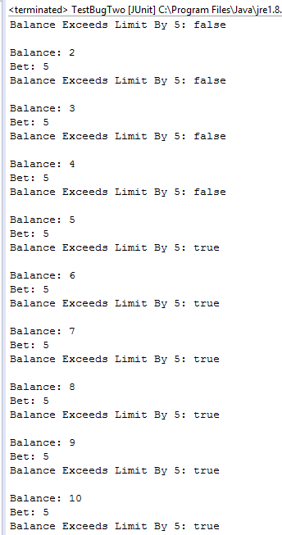

The test returns “true,” meaning the user can place one final bet, without exceeding the betting limit.

| **Test Name** | | Limit Bug 2 |
| --- | --- | --- |
| **Use Case Tested:** | | Betting Limit |
| **Test Description:** | | User should be able to observe that the game will end when the player’s balance reaches 0 dollars. |
| **Pre-conditions** | | * Console Exists * Game Exists * 3 Dice Exist * Player Exists Player has declared their bet Player’s Balance exceeds their bet declaration * totalWins, totalLosses, winCount, loseCount and turn are initialized to Zero |
| **Post-conditions** | | * Correct Results are being displayed in the Console of the IDE * Individual Games end, and the program continues to run |
| **Notes:** | **We are testing if the Betting Limit bug has been resolved (the individual game ending when the player’s balance reaches zero)** | |
| **Result (Pass/Fail/Warning/Incomplete)** | **Pass – Bug 2 resolved** | |

|  | **TEST STEP** | **EXPECTED TEST RESULTS** | P | F |
| --- | --- | --- | --- | --- |
|  | User runs Main.java | Program executes and results can be seen in the console | X |  |
|  | User can observe the fluctuation in the player’s Balance. | The user can observe when the player’s balance reaches 0, the game ends. | X |  |